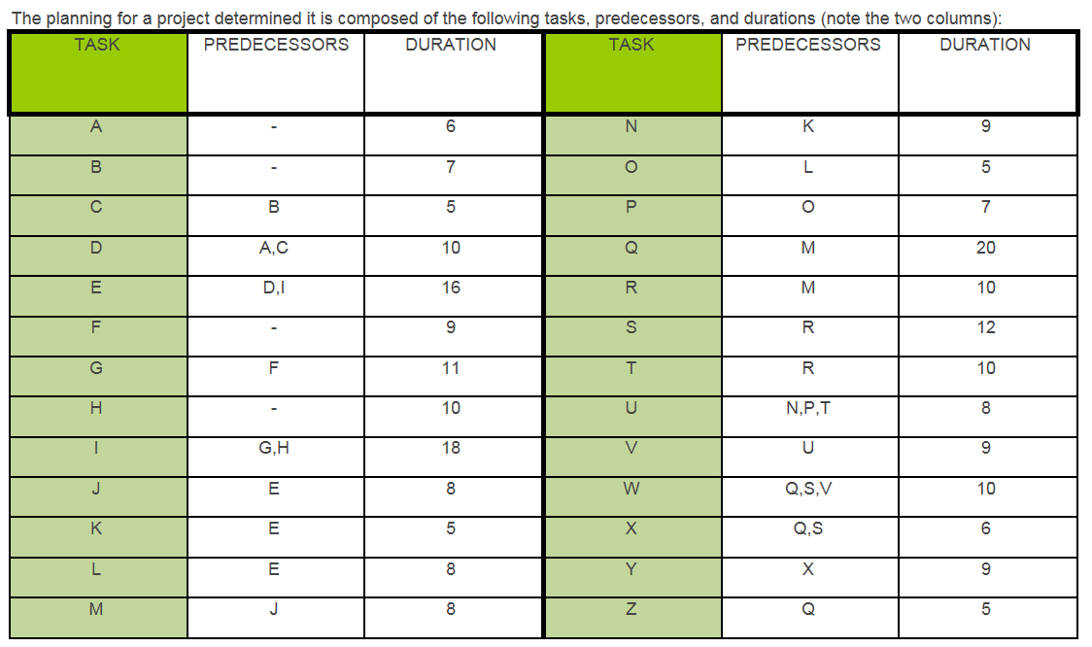
- Without using any software package, manually construct the appropriate CPM network diagram using the activity on arrow convention and the techniques discussed in the class. You must submit your diagram for full credit:
Address the following:
(a) For each task, give the Earliest Start, Latest Start, Earliest Finish, Latest Finish, and Total Float.
(b) What sequence of tasks makes up the Critical Path? Include any dummy activities that may be a part of the critical path.
(c) What is the total duration of the project as planned?

